GBL_HLTH 390: Indigenous Foodways:

Cultivating Mind, Body, and Soul

Course Description:
Explore the profound connection between Indigenous food, culture, and well-being in this illuminating course. Delve into the cultural relevancy of foods, tracing their origins and understanding their foundational role in Indigenous origin stories. You'll discover how food serves as medicine for the mind, body, and soul, and learn to approach cooking from a place of spirit and love.

This course also examines the vital food sovereignty movement, exploring the environmental impacts on traditional foodways and their far-reaching effects on Indigenous cultures. Develop a holistic understanding and relationship with food, from seed to soil to plate, and uncover the rich heritage embedded within Indigenous culinary traditions.

Taught by Executive Chef Jessica Walks First (Menominee), Illinois’ first professionally trained Indigenous chef, and owner of Ketapanen Kitchen, this class will include interactive lectures, discussions, and active cooking in a teaching kitchen on campus.

Entry to the class is by application only. Selected students will be notified by July 30th if they have been selected, and are expected to enroll within 48 hours of notification in order to secure their place in the class.

Application for GBL_HLTH 390: Indigenous Foodways, Fall 2025

Please fill out the following application, and email it to GlobalHealth@northwestern.edu. Deadline is June 30th.
Name:
Email Address:
Questionaire:
- In fall 2025, what year will you be in at Northwestern?

- Major(s)/Minor(s):

- How comfortable are you working in a kitchen? (circle one: 1=uncomfortable to 5=self proclaimed chef)
1 2 3 4 5
- How much cooking experience do you have? (circle one: 1=None to 5= self proclaimed chef)

1 2 3 4 5

- Do you cook for others? Y / N
- If yes, how often do you cook for others?

- What are your favorite dishes to cook?

- Are you comfortable using Chef knives and other kitchen sharps? Y / N

- Why do you want to take this class?

- What do you hope to learn in this class?

- Anything else you think we should know?

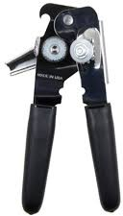
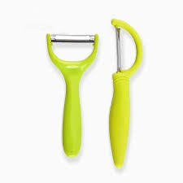
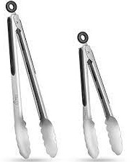
Can Opener Peeler Grater Tongs
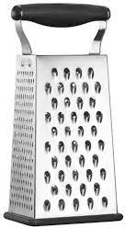

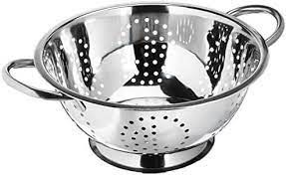
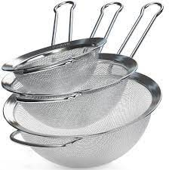
Colander Small Mesh Strainer

